MAPR training on 6th Aug 2018 Day 1

* NameNode: Master node jobs
* DataNode: data blocks read and write
* HDFS: file system. Read and write parallel. But processing take time on local nodes.
* Federation HDFS can have multiple Name nodes.
* UHG gets 3TB data per week
* Default replication is 3
* Belling HDD 24TB, Mem 96GB, 10 Core processor.
* 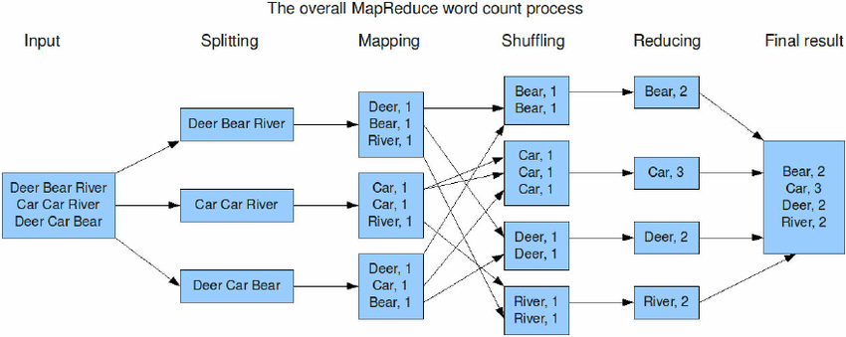
* Ex: week=9TB, MAPReduce=3TB, Othe=.75TB
* <http://learn.mapr.com/series/administratorv6/adm-200-install-a-mapr-cluster-mapr-v6>
* User: vurachaitanya/B143